Rough justice: 80 lashes for 'immoral' Iranian who abused alcohol and had sex
by DAVID WILLIAMS 22nd August 2007 UK Daily Mail

His face covered by a balaclava, an official brandishing a cane repeatedly lashes the back of a man found guilty of breaking Iran's morality laws. Two police officers hold the legs of 25-year-old Saeed Ghanbari and another his arms to ensure there is no escape from the punishment of 80 lashes handed down by a religious court.
Traffic was brought to a halt in Qazvin, 90 miles west of the capital Tehran, as more than 1,000 men gathered behind barricades to watch the public flogging.
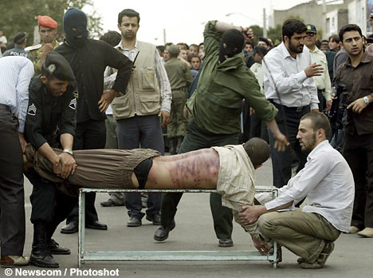
Saeed Ghanbari receives 80 lashes for abusing alcohol and having sex outside marriage
Some took pictures on mobile telephones, others climbed traffic lights for a better vantage point as Ghanbari was marched to the centre of the square under the watch of blue-uniformed guards carrying machine guns. A four foot long metal bench was taken from a police van and the convicted man was made to lie on it on his stomach, his fawn checked shirt pulled-up to his shoulders to expose his back and waist.
One police officer held his hands together beneath the bench, two others gripped his legs to ensure there was little movement. Two police officers stood-by, their faces covered with balaclavas - each to administer 40 lashes. Both men then lashed Ghanbari, taking the cane back behind their heads to guarantee maximum impact, each stroke leaving a distinctive red mark and bruising on his back. Several wounds began to bleed.
It was unclear exactly what his offence had been as the country's strict morality laws cover many areas, but it was reported he had been convicted of abusing alcohol and having sex outside of marriage. The public lashings have been endorsed by the judiciary as a way of deterring alcohol abuse at a time when it is on the increase among young men but some religious leaders are said to be questioning their validity, fearing they have an adverse impact on the country's image abroad.
Although men and women convicted of flouting public morals are routinely flogged in detention centres, public floggings are considered rare. Human Rights groups say there have been a marked rise in recent months in the number of people sentenced to executions and floggings in Iran.
Amnesty International, which said it is "greatly concerned by continuing human rights abuses in Iran", has highlighted figures revealing 117 people were executed in 2006 with thousands facing floggings. They included a woman, who had been forced into prostitution as an eight-year-old, receiving 99 lashes because of "acts contrary to chasity."
Earlier this year, a man was flogged after a copy of the Bible was found in his car. At least 120 executions have been recorded so far this year, according to Amnesty, with two youths under the age of 18 when they committed their crimes among those killed.
The latest gruesome pictures have emerged three weeks after there was an outcry over a video of a flogging in a Malaysian jail was posted on the Internet. The sickening images showed a man being lashed repeatedly on the buttocks until he bled from several wounds.
http://www.dailymail.co.uk/pages/live/articles/news/news.html?in_article_id=477088&in_page_id=1770

