P.I.GOV H NAME: PER:

Study Guide: Aldous Huxley, Brave New World

Mustapha Mond, World Controller:
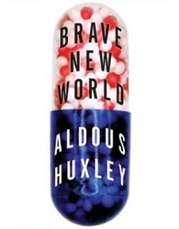
The world's stable now. People are happy; they get what they want, and they never want what they can't get...They’re well off, they’re safe, they never get ill; they’re not afraid of death; they’re blissfully ignorant of passion and old age; they’re plagued with no mothers and fathers; they’ve got no wives, or children, or lovers to feel strongly about; they’re so conditioned that they practically can’t help behaving as they ought to behave. And if anything should go wrong, there's soma. Which you go and chuck out of the window in the name of liberty, Mr. Savage. Liberty!...

Huxley wrote Brave New World (published in 1932) to warn us about methods of totalitarian control; how a government might reduce people to unthinking, obedient slaves. He also intended to illustrate to the reader how people could ultimately prefer a comfortable and entertaining slavery to the risks and difficulties of freedom; how the erosion of the core values of a free society would result in not only the loss of liberty, but also the loss of our humanity.

I. As you read Brave New World, consider how this future world contrasts with the principles of civic virtue and republicanism.

- How is society organized in the year “632 After Ford” (2540 A.D.)?
- What are the methods of control used by the World Government?
- What is SOMA, and what might it represent in our society today?
- In what ways is the World Government in the story a totalitarian government?
- The way people are controlled in this story differs greatly from the methods of control describe in Orwell’s 1984. Which approach do you think is more effective (and therefor dangerous)?

II. How much about our political tactics and government today mirror elements of the society described in Huxley’s story?

Keep an eye on the latest news. Save articles and /or opinion pieces from reputable sources that discuss examples which might reflect Huxley’s warnings. You can use these sources in a forthcoming extra credit writing assignment.

The Savage:

…But I don’t want comfort.
I want God, I want poetry, I want real danger,
I want freedom,
I want goodness.
I want sin.

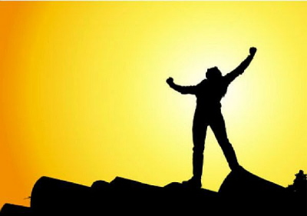

TENTATIVE TEST DATE FOR BRAVE NEW WORLD : ________________________

BRAVE NEW WORLD PRE READING QUESTIONS

Are many people unhappy with their situation in life?

Do many people make bad decisions in life that hurt them?

Do people often engage in risky or dangerous behaviors in general?

Should it be government’s responsibility to making people happy? To guarantee that our needs are met?

Are most people capable of making good decisions in their lives? Should the government control us for our own good?

Should we give up choosing for ourselves and oblige the government to take responsibility for:

What we eat and drink and put into our bodies?
Exercise and fitness?
Keeping us happy?
Keeping us safe?
Healthy, positive, and socially responsible thinking?

If we accept that we need to be managed by the government for our own good…
What will we be giving up?

