P.I.GOV H NAME: PER:

Study Guide: Aldous Huxley, Brave New World

Mustapha Mond, World Controller:
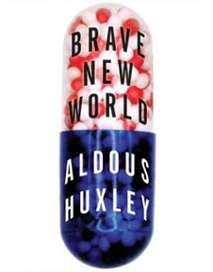
The world's stable now. People are happy; they get what they want, and they never want what they can't get...They’re well off, they’re safe, they never get ill; they’re not afraid of death; they’re blissfully ignorant of passion and old age; they’re plagued with no mothers and fathers; they’ve got no wives, or children, or lovers to feel strongly about; they’re so conditioned that they practically can’t help behaving as they ought to behave. And if anything should go wrong, there's soma. Which you go and chuck out of the window in the name of liberty, Mr. Savage. Liberty!...

Huxley wrote Brave New World (published in 1932) to warn us about methods of totalitarian control; how a government might reduce people to unthinking, obedient slaves. He also intended to illustrate to the reader how people could ultimately prefer a comfortable and entertaining slavery to the risks and difficulties of freedom; how the erosion of the core values of a free society would result in not only the loss of liberty, but also the loss of our humanity.

I. As you read Brave New World, consider how this future world contrasts with the principles of civic virtue and republicanism.

- How is society organized in the year “632 After Ford” (2540 A.D.)?
- What are the methods of control used by the World Government?
- What is SOMA, and what might it represent in our society today?
- In what ways is the World Government in the story a totalitarian government?
- The way people are controlled in this story differs greatly from the methods of control describe in Orwell’s 1984. Which approach do you think is more effective (and therefor dangerous)?

II. How much about our political tactics and government today mirror elements of the society described in Huxley’s story?

Keep an eye on the latest news. Save articles and /or opinion pieces from reputable sources that discuss examples which might reflect Huxley’s warnings. You will use these sources in a forthcoming writing assignment.

The Savage:

…But I don’t want comfort.
I want God, I want poetry, I want real danger,
I want freedom,
I want goodness.
I want sin.

