P.I.GOV H NAME: PER:

Study Guide: George Orwell, 1984

Orwell writes in the Appendix of 1984:

When Oldspeak had been once and for all superseded, the last link with the past would have been severed…
[Pieces of old literature], even if they chanced to survive, would be unintelligible and untranslatable… Take for example the well-known passage from the Declaration of Independence:

We hold these truths to be self-evident, that all men are created equal, that they are endowed by their Creator with certain unalienable Rights, that among these are Life, Liberty and the pursuit of Happiness. — That to secure these rights, Governments are instituted among Men, deriving their just powers from the consent of the governed, — That whenever any Form of Government becomes destructive of these ends, it is the Right of the People to alter or to abolish it, and to institute new Government...

It would have been quite impossible to render this into Newspeak while keeping to the sense of the original. The nearest one could come to doing so would be to swallow the whole passage up in the single word crimethink.

Orwell wrote 1984 (published in 1949) to warn us about methods of totalitarian control; how a government might reduce people to unthinking, obedient slaves. He also intended to illustrate to the reader how any ambitious people in positions of power or influence can manipulate others for their own ends. These manipulations do not require a totalitarian dictatorship in order to be effective, which is probably why so many of Orwell’s terms are used to describe our politics today.

I. As you read 1984, consider how the dystopia he described contrasts with the natural law founding principles of the United States outlined in the Declaration of Independence.

- What are the ways Ingsoc works to eradicate all recognition of objective truth?
- How does the government of Oceania constantly work to replace reason, logic, and critical thinking with emotion? How is hate used as a mechanism of control?
- What is the Ingsoc approach to equality and rights?
- How does the idea of limited government by consent of the governed contrast with the government of Big Brother?
- How effective is the government of Oceania in preventing any serious challenges to its authority?

II. How much about our political tactics and government today are Orwellian?

Keep an eye on the latest news. Save articles and /or opinion pieces from reputable sources that discuss examples which might reflect Orwell’s warnings. You will use these sources in a forthcoming writing assignment.
III. Story, characters, terms, and Newspeak

Make sure you know the main characters, settings, plot, and the vocabulary. Know your NEWSPEAK!
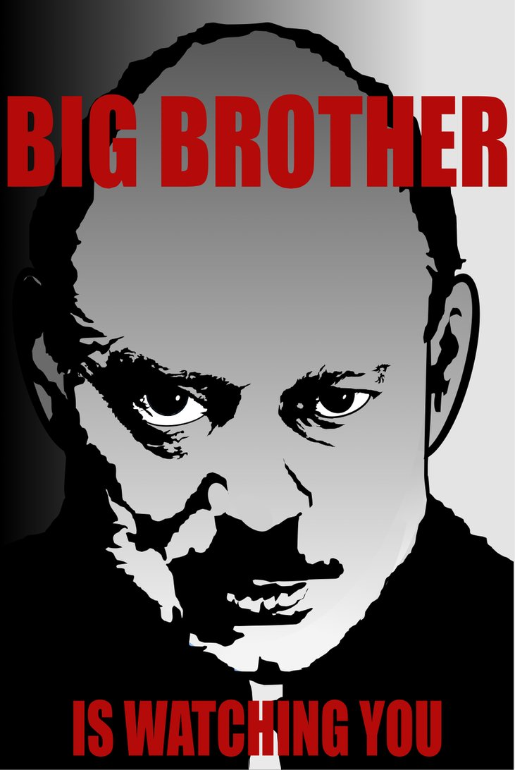

"1984" 60 Years Later
By Cathy Young - June 11, 2009 realclearpolitics.com
This week marks the 60th anniversary of perhaps the most famous book of the 20th Century: George Orwell's "1984." It is a book that changed our language, giving us such words and phrases as "thought police," "newspeak," "doublethink," and "Big Brother" - not to mention "Orwellian." But what is the relevancy of Orwell's disturbing novel today? Is it a warning about future horrors that may come if we fail to guard our freedom? Does it talk about things that are already present in our lives?

Orwell, the British journalist and writer, penned his book in 1948 as a commentary on Soviet totalitarianism, a very present danger at the time. His dystopia was in many ways an even darker version of Stalin's Soviet Union, with a godlike leader, a ruling party that enforces the state's ideology, and an omnipresent secret police. Yet Orwell was a socialist, a man of the left whose polemic was directed in large part at the pro-Soviet delusions of his fellow leftists. Since then, both left and right have tried to appropriate Orwell's vision and claim it as their own.

The most recent such appropriation comes from the right. The Competitive Enterprise Institute, which opposes increased regulation, used the anniversary to put out a press release arguing that "the crusade for global governance led by environmental activist groups in the name of combating global warming" represents a "1984"-style threat to personal freedom today. The CEI has released a video clip based on the famous "1984"-themed Apple Computer ad in which Al Gore appears as Big Brother lecturing a zombie-like captive audience in gray uniforms on the perils of global warming.

Whatever one may think of climate change, such imagery and rhetoric runs the risk of trivializing the evil of true totalitarianism - and discrediting one's own argument, except in the eyes of those who need no convincing. Al Gore is not planning to establish secret dungeons where people will be horribly tortured until they see the error of their ways, any more than George W. Bush - a frequent target of accusations of Orwellian malfeasance - was planning to brainwash the unpatriotic into submission.
Orwell's concern was not with a democratic government's excessive regulatory powers, or excessive national security powers (in the Cold War years, he himself shared a list of communist sympathizers and possible Soviet spies with an intelligence agency in the British Foreign Office). It certainly wasn't with the ability of corporations to track customers' buying habits, which some privacy advocates have likened to Big Brother's watchful eye.

The oppressive machine in "1984" is a tyrannical state that maintains total control over the lives and even thoughts of its subjects and brutally crushes all dissent. It is unchecked power, "a boot stamping on a human face - forever." The closest any political force comes to this nightmare vision today, besides such communist relics as North Korea, is Taliban-style Islamist radicalism.
Yet "1984" does have lessons beyond the totalitarian experience. Take the book's definition of "doublethink," the ideal mental state of the citizen of Orwell's dystopia: it is "the power of holding two contradictory beliefs in one's mind simultaneously, and accepting both of them," the ability "to tell deliberate lies while genuinely believing in them, to forget any fact that has become inconvenient, and then, when it becomes necessary again, to draw it back from oblivion for just so long as it is needed, to deny the existence of objective reality and all the while to take account of the reality which one denies."

It is not just governments - democratic or not - that engage in a less extreme version of such mental gymnastics. It's activists of all stripes; talk show hosts and pundits across the political spectrum; and, finally, ordinary people. The same is true of "newspeak," terminology invented to shade the real meaning of certain beliefs or acts and make them more appealing. (Even such popular terms as "pro-choice" for "pro-abortion rights" and "pro-life" for "anti-abortion" have overtones of newspeak.)

Another pervasive feature of the Orwellian state was the practice of constantly whipping up hatred toward the ideological enemy du jour. Looking at much of our political discourse today, from right-wing talk radio to left-wing blogs, it's hard not to think of such rituals as "Two-Minute Hate" and "Hate Week." On too many political websites, every week is Hate Week - whether the object of hate is liberals, Muslims, neocons, or Christian bigots. Partisan propagandists and professional hate-mongers bear a large share of the blame, but so do "regular" people who need little encouragement to demonize political opponents.

The inhuman system that inspired Orwell's masterpiece has crumbled. But doublethink, newspeak, thought-policing and virtuous hatred are eternal temptations of the human soul, even in the freest of societies. We have met Big Brother, and he is us.

Cathy Young writes a weekly column for RealClearPolitics and is also a contributing editor at Reason magazine. She blogs at http://cathyyoung.wordpress.com/. She can be reached at cyoung@realclearpolitics.com
Page Printed from: http://www.realclearpolitics.com/articles/2009/06/11/1984_60_years_later_96941.html at December 02, 2013 - 11:03:40 AM CST

