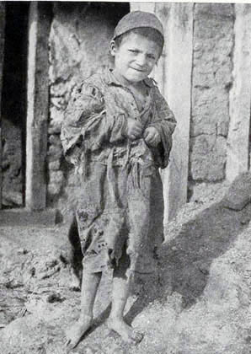
GENOCIDE COURSE OUTLINE PENNINO
classicalliberal.org

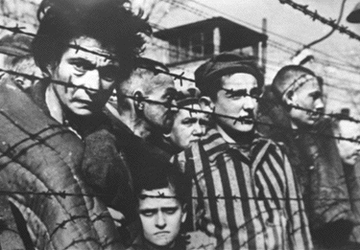
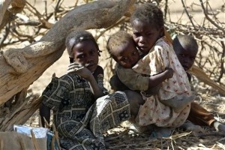

GENOCIDE: “…acts … to destroy in whole or in part a national, ethical, racial or religious group…” -Convention on the Prevention and Punishment of the Crime of Genocide

Genocide is a half year elective that focuses on both human behavior and atrocities committed throughout history. During the semester, you will gain an understanding and will explore examples of the following terms: “genocide”, “crimes against humanity” and “war crimes”. This course investigates examples of genocide and mass murder in the twentieth and twenty-first centuries, including but not limited to events in Armenia and the Soviet Union; The Holocaust; the regimes of Mao and the Khmer Rouge; and recent events in Bosnia, Rwanda, and Darfur. We will explore the nature of hatred and evil, of collective identity, and explore how bias, stereotypes, prejudice, and discrimination impact various groups of people in society.

DISTRICT TESTING / GRADING POLICY: Throughout the year, students will take quizzes and/or tests related to the content and general grade level concepts. As assessment is the best way to monitor instruction and provide targeted support, all tests/quizzes are counted in the average of the quarter they are given, except for pre-assessments at the beginning of the year, which are used to gauge where students are prior to the start of the course. Although some end of the year assessments are secure and cannot be reviewed with students in detail, they all cover key concepts that students are learning throughout the year. Students should take these exams seriously and should prepare and study.

CLASS REQUIRMENTS

- Consistent attendance and effort
- Be on time to class
- Be respectful to others
- Follow all school rules

GRADING SYSTEM

- Participation, effort
- In class assignments
- Exams
- Essays
- Quizzes
- Final Exam

NOTES ON CLASS STRUCTURE

- This course involves regular in class and at home readings. Both primary and secondary sources are utilized.
- Written work, in the form of opinion, evaluation, and reflection writings, is assigned on a regular basis. This may be completed in class or as homework.
- Respectful discussions and participation are central to our approach in this class. All present must be treated in a polite manner, regardless of disagreements.

FINAL EXAM EXEMPTIONS.
To be exempt from the final, ALL of the following must be true:
90 average between both quarters, no more than 10 absences and latenesses between both quarters, a 90 assignments average, all tests taken in timely fashion, final review packet submitted on time.

COLLEGE CREDIT
This course is offered for college credit through L.I.U. CW Post.

“

Be the change you wish to see in this world.”
--Gandhi

