Ethics Bowl Commentary Strategy

The goal of commentary is to advance the conversation by responding to the opening argument(s) presented by the other team. The presenting team is supposed to present an argument, the conclusion of which answers the question posed by the moderator. The commenting team is supposed to respond to that argument.

What is an argument? An argument is a series of propositions (propositions are sentences that are either true or false) that are connected in such a way that the premises purport to logically entail the conclusion. Arguments can be deductive or inductive. See graphic below.

If a deductive argument is valid, that means that its structure is such that logically if the premises are true, then the conclusion must be true. Deductive arguments can be valid but unsound if any one of the premises is false. All kangaroos are purple; all purple things are from Mars; therefore all kangaroos are from Mars is logically valid, but the premises are false, so it does not follow that the conclusion is true. There is no use in arguing against a conclusion of a deductive argument if you believe the argument is sound.

Inductive arguments are probabilistic arguments wherein the premises combine to build a case for the likelihood of the conclusion. We call inductive arguments that have premises that logically entail their conclusions strong and strong arguments that have all true premises cogent. An argument that says 95% of the marbles in this jar are red, and I just drew a marble at random, so it is most likely red is a strong argument, but if in fact only 5% of the marbles are red, then my argument is not cogent.
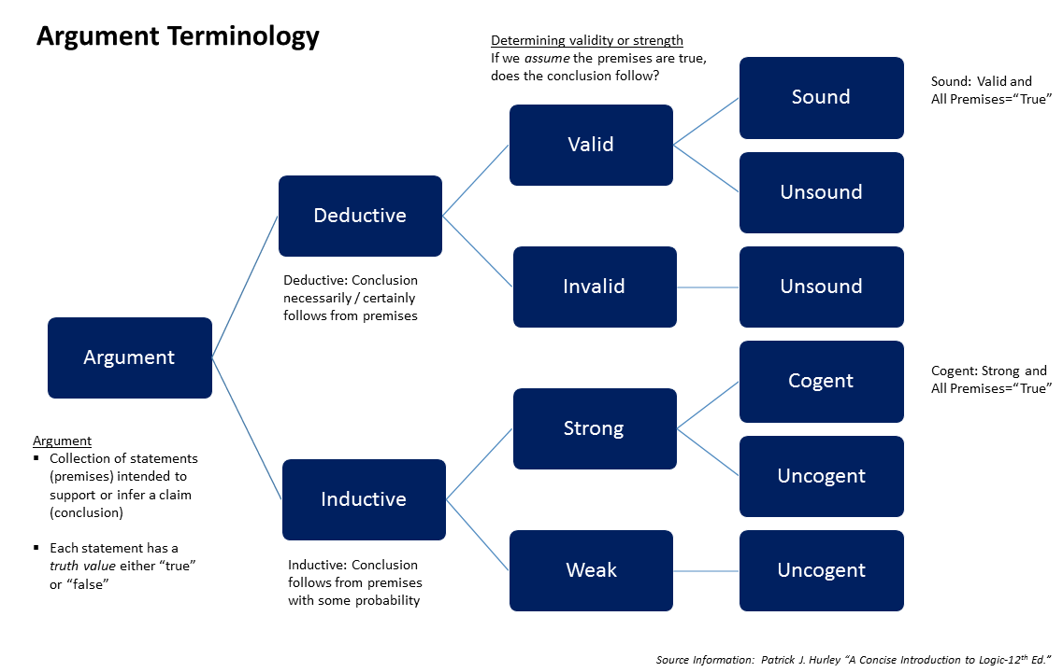

What to Do
Commentaries are responses to the arguments of the other team, so commenting teams should:

- Listen and take strategic notes. Do not try to write down every word. Focus on the core argument.
- Identify the major moral principles on which their case is based.
- Identify which facts of the case they connected to their major moral principles to draw their conclusion.
- Restate the conclusion they drew from the major moral principles and the facts of the case.
- Did their argument answer the question?
  - If yes, then move on to analysis of that argument.
  - If no, then acknowledge that they did not answer the question but try to construct what their answer would have been on the basis of the moral principles they identified.
- Was their argument valid/sound?
  - If yes, then acknowledge that.
  - If no, then explain where their argument went wrong and suggest a better one.
- Were their premises true?
  - If yes, then acknowledge that and either test their convictions by changing the facts of the case or by creating a parallel scenario that puts pressure on their moral intuitions OR play devil’s advocate.
  - If no, then raise objections to their major moral principles or their interpretation of the facts of the case.
- Did they satisfactorily identify all of the other opposing positions to their own? If not, ask them to explain why someone who disagrees with them would do so and how they would respond.

What Not to Do
Since the goal of the commentary portion of an Ethics Bowl round is to advance the argument, teams should not to do the following:
- Thank the other team and the judges for being here. Teams only have four minutes, so the best way to respect everyone in the room is to give the presenting team’s argument all the attention it deserves.
- Present their own team’s argument on the case. This is not a second presentation round.
- Overwhelm the other team with so many questions they could never possibly answer them during the response. This debating tactic has no place in Ethics Bowl.
- Try to make the other team look unintelligent.
- Raise irrelevant points or ask irrelevant questions to the question at hand.
- Use a sneering or apoplectic tone of voice.

Response Strategy
The response section is a lot like the commentary section in that the goal is to advance the conversation after having listened to the other team. A major difference is that in the response section, you will have been asked questions and responding to critiques you may not have been anticipating. It is important for a response to be responsive. Teams should thus avoid repeating arguments that have already been clearly made. They should not treat the response section as a second presentation round. Rather, they should listen to the commenting team and analyze the points they made and respond to the relevant questions or criticisms they raised.

What to Do
- Listen and take notes.
- Restate the commenting team’s strongest objections or suggestions.
- Thank them for suggestions that will advance your argument and explain why those suggestions are helpful.
- Did the other team’s objections make you rethink your argument?
  - If yes, acknowledge that and develop a new argument in light of what you have learned?
  - If no, respond to the objection.
- Did the other team ask you to consider a similar scenario that pressed your convictions on your major moral principle(s)? If so, show that you understand the force of their argument and then decide if you want to stand by your principle(s), argue that the scenario they have presented is exceptional and give reasons why such exceptions are consistent with holding your principle(s) in the original case, or abandon your argument in favor of a new one.

What Not to Do
- Ignore or downplay strong objections and cling to an argument that clearly has weaknesses
- Chase red herrings - If the commenting team has showered you with questions or raised irrelevant points, do not take the bait.
- As the commenting team questions. They do not get a chance to respond.
- Be defensive or indignant
  - Insist the other team misunderstood or misheard you
  - Simply restate the arguments you made in the presentation
  - Express frustration or condescension in your tone of voice

